1. Network Diagram
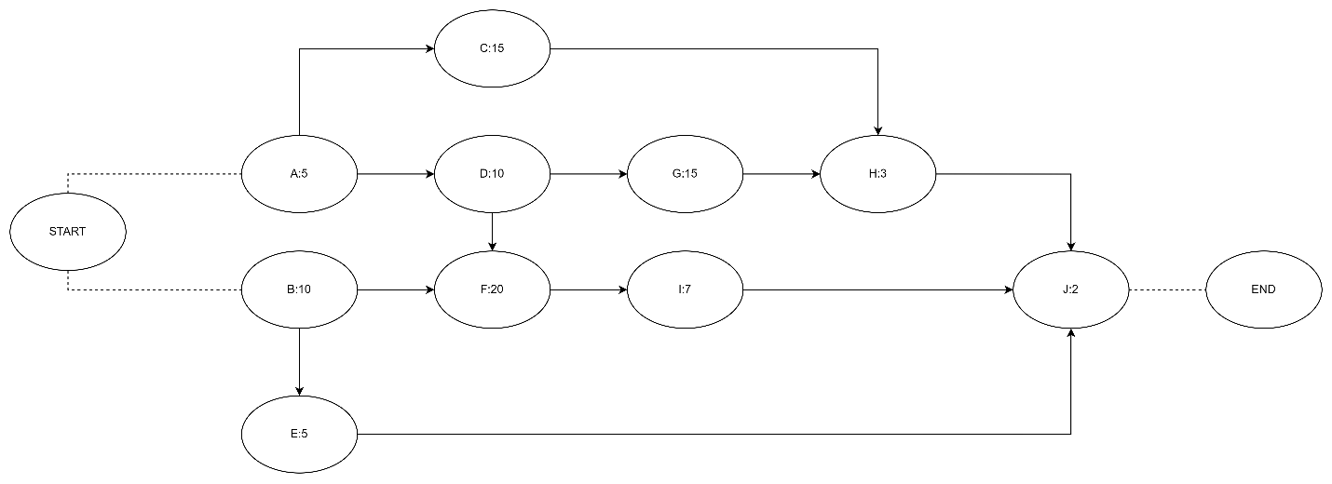

2. CPM Analysis (Forward & Backward Pass)
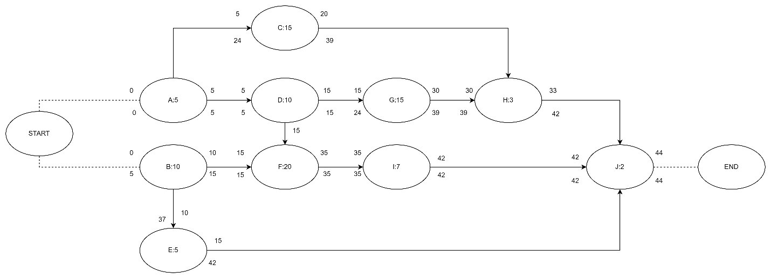

3. Critical Path & Duration
The total duration of the project is 44 days.
The activities on the Critical Path are: A, D, F, I, J. This is the longest sequence of activities in the project and any delay in these activities will delay the entire project.

4. Slack Calculation
Hoạt động | Tính toán (LS - ES) | Tổng thời gian dự trữ (Ngày)
A | 0 - 0 | 0
B | 5 - 0 | 5
C | 24 - 5 | 19
D | 5 - 5 | 0
E | 37 - 10 | 27
F | 15 - 15 | 0
G | 24 - 15 | 9
H | 39 - 30 | 9
I | 35 - 35 | 0
J | 42 - 42 | 0

Activities that have “free slack”, i.e., can be delayed without affecting the activity that immediately follows it, are:
- Activity C: Can be delayed by up to 10 days without affecting the early start date (day 30) of activity H.
- Activity E: Can be delayed by up to 27 days without affecting the early start date (day 42) of activity J.
- Activity H: Can be delayed by up to 9 days without affecting the early start date (day 42) of activity J.

5. Effort Calculation
Total effort = 10 (A) + 15 (B) + 20 (C) + 25 (D) + 10 (E) + 10 (F) + 20 (G) + 5 (H) + 5 (I) + 30 (J) = 150 person-days

6. Analysis Question (Bonus)
A 10-day delay in activity C will not affect the final project deadline.
Reason:
- Activity C is not on the critical path.
- Based on the calculation above, activity C has a total slack of 19 days.
- The expected delay is 10 days, which is less than the allowed slack (10 < 19).
- Therefore, this activity has enough time “buffer” to absorb this delay without changing the critical path or extending the total project duration of 44 days. Activity C’s slack will be reduced from 19 days to 9 days.

